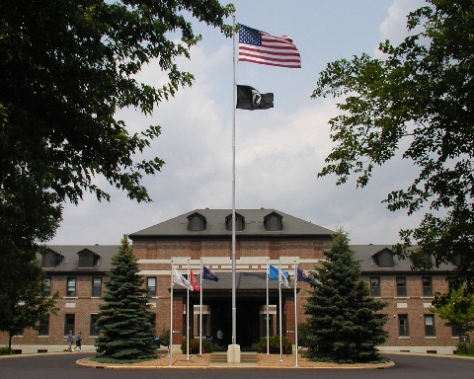

2026-2027 CPE Residencies – October 5, 2026-October 4, 2027
St. Cloud VA HCS, St. Cloud, MN

St. Cloud VA HCS CPE Center is accepting applications for the 2026-20267CPE Resident program for the St. Cloud VA. This is a 12-month, 4-unit program starting October 5, 2026 and ending October 4, 2027. At St. Cloud VA, we have 4 stipend Resident I positions and 2 stipend Resident II Fellow positions. Residents have the opportunity to work alongside Chaplain Preceptors and the Interdisciplinary Team serving our men and women Veterans. Resident II requires 4 previous CPE units.

We have 9 stellar chaplain staff. At the St. Cloud VA, we serve the second largest VA Community Living Center, a hospice program, a robust Residential Rehabilitation Treatment Program, an Acute Psych unit, an expanding Adult Day Health Care program, and numerous connections with the outpatient population through Home Based Primary Care, Caregiver Support Program, various clinics, Whole Health, and ethics.

Our Certified Educator, Chaplain Dan Duggan, brings decades of experience, skillfulness, and innovation to our CPE program and trainees. At the St. Cloud VA, we expanded our second-year resident program to include tracks with Hospice/Palliative Care, Mental Health, and Moral Injury. These specialty tracks will explore residential and outpatient settings. The Mental Health track will include recovery, moral injury, and acute in-patient psych programs. Our Chaplain Team is exceptionally integrated into our Mental Health and Rehabilitation and Extended Care (REC) service lines. Our interdisciplinary colleagues value our input and see the impact spiritual care may have on Veterans and their loved ones.

St. Cloud VA HCS is renowned for its high standards of care for our Veterans and preparing those who care for them to the highest standards of care. Stipend for the STC VA Resident I is approximately $41,896 Resident II is $43,896. STC VA CPE Center also offers summer intern, extended, and CE Training programs. St. Cloud enjoys four seasons and is passionate about the year-round outdoor activities. We serve people of all ages, race, color, religion, sex, national origin, age, disability.

For more information about our CPE Residency, intern or extended unit programs, please call Chap. Dan Duggan, ACPE CE at 320-252-1670 x 7543, or email daniel.duggan@va.gov. You can find the ACPE application at this link: https://acpe.edu/education/cpe-students/cpe-application. You can send your application materials to daniel.duggan@va.gov or at St. Cloud VA HCS, 4801 Veteran’s Dr., Chaplains Office, St. Cloud, MN 56303. Come join our Team!

