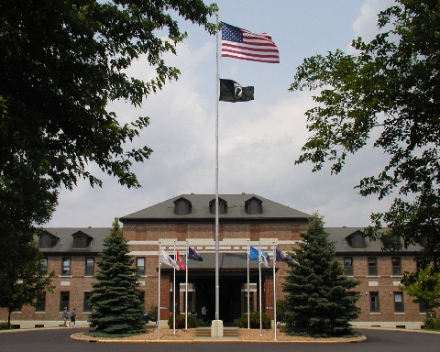
FY26 ACPE Summer CPE Unit Program
St. Cloud VA HCS CPE Center

Description: St. Cloud VA Health Care System is a Veteran Administration hospital setting in St. Cloud, Minnesota about 60 miles northwest of the Twin Cities. We serve Veterans of all ages, race, color, religion, sex, national origin, age, disability. We have long-term care, mental health and addictions, women’s issues, out-patient medical services, and a host of other services for veterans. What is unique about a VA hospital is that it serves our Veterans who have served our country in war and in peace time. One experiences the stories of Veterans through their military and civilian lives, hears about and has contact with families, works with the interdisciplinary team as a team member, and deals with crises as they arise. Obviously, one brings one’s own life experiences into the pastoral encounter as well. In CPE, one will work to gain self-awareness and then how to use that in ministry to help build the bridge between oneself and others in ministry. Our program will use family systems theories and other theories of human and faith development, theories on aging, grief, etc. There are eight full-time Chaplains in the Chaplain Services.

Please note these perks:

- The opportunity to minister with Veterans and their families.
- No application or tuition fees.
- Housing option for those needing that (see below).
- No on-call.

FY26 Summer CPE Program: No application or tuition fees.
  - Dates and times
    - May 26-August 7, 2026
    - 7:45 a.m. – 4:15p.m.
    - Monday-Friday
  - Housing option for St. Cloud VA students is available through St. John’s School of Theology in Emmaus Hall:
    - Dormitory style housing
    - Building is co-ed
    - A graduate residence hall, for full-time resident students and students who will be coming in for our summer session (primarily in June).
    - Room rates for students who would be living here throughout the summer, full-time 74 days: (this may change so contact Patty Weishaar for up to date info.)
      - Single room = $1100
      - Suite = $1480
    - Room rates for students who would be coming and going:
      - Single room = $825 for the 11 weeks
      - Suites = $1100 for the 11 weeks
    - Rooms are comfortable and Saint John’s campus is lovely
    - Furnished rooms, linens and towels provided if desired
    - Shared common kitchens with pots and pans and dishes provided
    - All utilities; Wifi; Free laundry machines
    - Close by parking, no fee
    - Building is not air conditioned
      - Fans available and suites have ceiling fan
      - AC units are not provided. If needed for health reasons/other, residents may bring a SMALL AC unit – personnel will install/remove for fee of $100
    - Meal plans at the University refectory can be arranged
      - There are common kitchens for light cooking with utensils
      - Can bring small fridge for one’s room if desired
    - Smoke free and we do not allow pets
    - To apply for housing, please use the Housing Application at this link: https://www.csbsju.edu/sot/sem/housing-form. (Note—this is the school year application but it gives St. John’s the necessary data for your stay at Saint John’s.)
      - Talk directly with Patty Weishaar, PWEISHAAR@csbsju.edu, 320-309-4636

For further information contact Chaplain Dan Duggan at the information below or find an ACPE application at https://acpe.edu/education/cpe-students/cpe-application. Complete application and send to both Chaplain Duggan and Chaplain Wilson.

Rev. Daniel R. Duggan, M.Div., BCC, ACPE Certified Educator
Chaplain, ACPE Certified Educator
St. Cloud VA HCS
4801 Veterans Drive
St. Cloud, MN 56303
320-255-6480 x7543
Daniel.Duggan@va.gov

Chaplain Kenzie Wilson, M.Div., BCCi, ACPE CEC
Chaplain, ACPE Certified Educator Candidate
St. Cloud VA HCS
4801 Veterans Drive
St. Cloud, MN 56303
320-255-6480 x6040
Kenzie.Wilson@va.gov

