**First Baptist Church, Avon SD**

Contact information:

First Baptist Church

412 Main, P.O. Box 405

Avon, SD 57315

**605-286-3656**

[**fbc@goldenwest.net**](mailto:fbc@goldenwest.net)

facebook page – Avon First Baptist Church

**First Baptist Church, Avon SD**

**Pastoral Profile/Job Description**

First Baptist Church, Avon, South Dakota, is seeking a full-time senior pastor. We are an established, mission minded church with a rich spiritual history located in Southeastern South Dakota. We currently have 82 active members. On Sundays, First Baptist Church offers Sunday School for all ages with an average attendance of 35, and Sunday morning worship with an average attendance of 56. There is a young adult small group initiated by church members but including others from the community. Wednesday evening the AWANA program is offered with an average attendance of 30 students and 10 leaders.

Areas of ministry the church sees as priorities are Bible-centered preaching and teaching, prayer, children’s ministry, Godly leadership, and youth ministry.

As a church we feel the most important qualities in our pastor are:

* Effective Communication – 2 Timothy 4:1-2 1 Corinthians 2:12-14 Communicates God’s Word and reveals the person of Jesus Christ with clear relevant preaching and teaching. Able to effectively preach and teach God’s Word so as to bring about Godly change in people’s lives. Willing to faithfully preach the Word even when it is contrary to societal norms.
* Evangelism – 2 Timothy 4:5 Reveals God’s Good News, both practically and verbally, to people of all cultures inside and beyond the church facility.
* Shepherding and Pastoral Care – 1 Peter 5:2 Attentively provides pastoral care to and counsels congregation.
* Spiritual Oversight – Acts 20:17-18 Maturely models and teaches godliness and Christian commitment, protects members of the church from error and wrong.

Job Description/Responsibilities:

* Preach in the Sunday morning worship service
* Take the lead in planning the worship service
* Lead the congregation in the Lord’s Supper the first Sunday of every month
* Participate in the local Ministerial Organization
* Lead in regard to Baptisms
* Meet with deacons on Sunday mornings for prayer
* Provide pastoral care and servant leadership to those in need and willingness to advise the congregation and others in the community
* Visit members in the hospital and nursing home as needed
* Develops and sustains authentic relationships of all ages both within the church and the community
* Commits to the ministry of prayer and intercession
* Perform weddings and funerals
* Provide guidance to the congregation in regards to Bible studies, discipleships, or other small groups
* Support and maintain contact with all supported church missionaries and missions, both home and abroad
* Participate in and provide guidance in the Christian education of all ages, including Sunday School and AWANA
* Provide short term counseling as needed.
* Act as moderator of all meetings of the Church and Church Board
* Serve as ex-officio member of all boards, committees, and departments of the church
* Maintain accountability to deacons as laid out in the First Baptist Church Constitution
* Represent the church at Association and Triennial conference meetings and keep congregation informed of meetings and activities

Qualifications:

* Shall be a regularly ordained minister or eligible for ordination, and whose convictions are consistent with the Articles of Faith of the First Baptist Church Constitution and whose qualifications conform to 1Timothy 3:1-7
* Actively support/cooperate with the North American Baptist Conference, as well as the Central Plains Region Association
* Adhere to the statement of beliefs of the North American Baptist Conference and willing to sign the NAB Pastoral Code of Ethics.
* Master of Divinity, preferred

Send resumes to:

First Baptist Church Pastoral Search Committee

John Voigt, Chrmn

jvoigt@gwtc.net

General Church Information:

The breakdown of those regularly attending:

|  |  |  |  |
| --- | --- | --- | --- |
| AGE | MALE | FEMALE | TOTAL |
| 0-9 | 4 | 3 | 7 |
| 10-14 | 1 | 4 | 5 |
| 15-19 | 3 | 3 | 6 |
| 20-29 | 1 | 2 | 3 |
| 30-39 | 2 | 2 | 4 |
| 40-49 | 2 | 3 | 5 |
| 50-59 | 3 | 3 | 6 |
| 60-69 | 5 | 5 | 10 |
| 70-79 | 2 | 1 | 3 |
| 80+ | 9 | 11 | 20 |
|  |  |  | 69 |

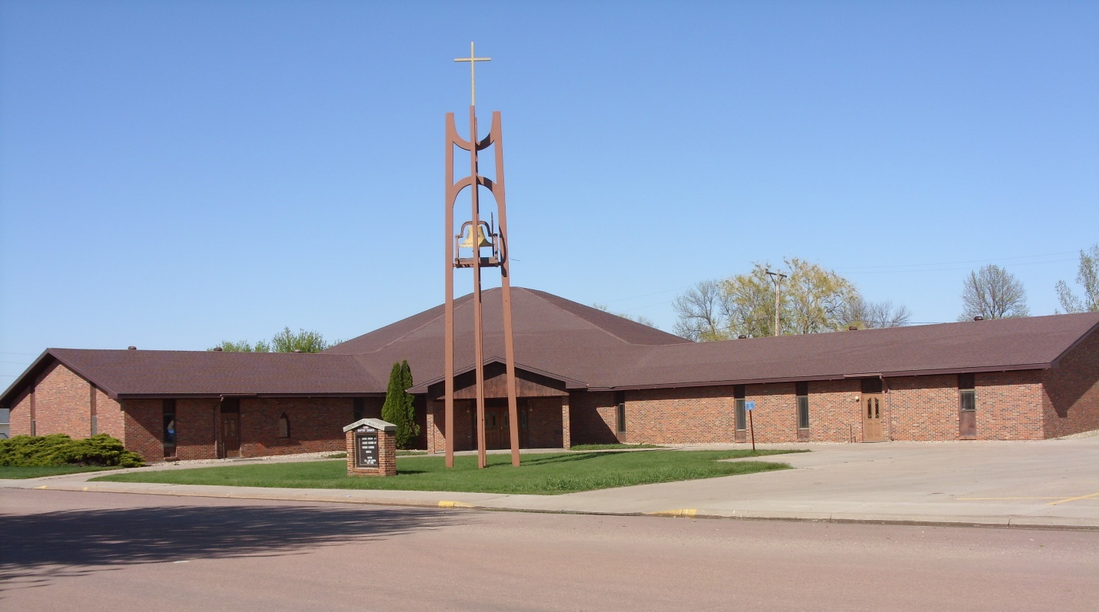

Our church building was dedicated in June of 1985. It features the sanctuary in the center of the building and a wing with the fellowship hall and kitchen and the other wing has Sunday School rooms.

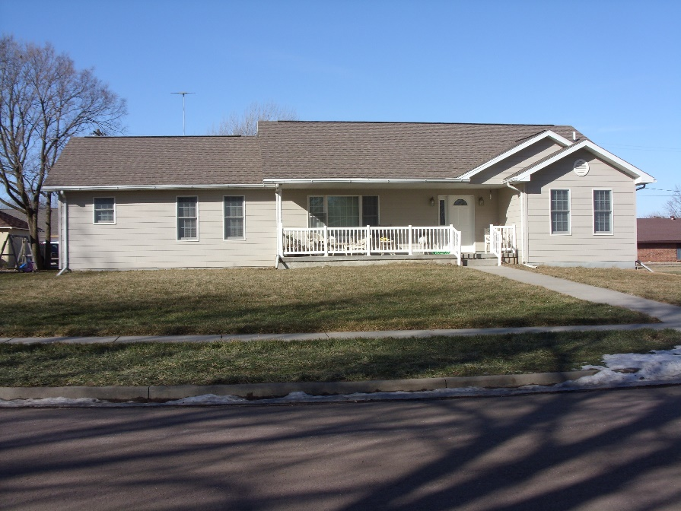

The church parsonage was built in 2003. It has a full basement, 5 bedrooms, and 3 full baths.

History:

Over a century ago in 1886 two Baptist families of the Aplington, Iowa church settled in Bon Homme County near the area that is now Avon, SD. These families had a deep and simple faith in their fellow man and an underlying belief in God. For this reason they felt it was necessary to meet together to worship God. First, they formed a Sunday School and met in two schoolhouses. The Rev. O. Olthoff from the newly organized church at Emery, SD frequently preached at the services. It was his belief that Dakota Territory ought to be “conquered” for Christ.

In 1890, by the grace and blessing of God, the group near Avon prospered and grew numerically to twenty-four. They were accepted into the membership of the mother church at Emery. On December 15, 1890, the Emery Church called a council and after an examination of the doctrinal beliefs of the Avon believers, it unanimously voted to recognize this congregation as a church.

The first church was built measuring 22 feet by 32 feet in 1891 at a cost of one thousand five hundred dollars with volunteer labor and with some financial help from Emery, the mother church. In the fall of 1901, the parsonage was built. In a few years, the small church was inadequate to accommodate the growing congregation and it was sold. A second church building was constructed in the City of Avon and was finished and dedicated on March 4, 1906. In need of additional space in 1954 an addition 20 feet by 56 feet was added to the west side of the church. This addition along with some smaller changes served the church well until 1982 when there was a need to consider repair to the church, renovating it, or replacing the building. In 1983, it was agreed upon to build a new church and one that would be more handicapped accessible. A groundbreaking service was held August 19, 1984. The building process progressed with much of the work being done by volunteering church members. On Sunday, June 23, 1985, the dedication service of the new church was held during which the cornerstone was cemented into place. The cornerstone was inscribed “Dedicated to the Glory of God” June 23, 1985. On July 17, 1988, the retirement of the church building fund was celebrated.

In 1962, the first church parsonage was sold and a new church parsonage was built with volunteer labor closer to the church. In 2003, the second parsonage was sold and the third parsonage was built with the help of volunteer labor. This was completed and an Open House was held in September 2003.

In October 1990, a weekend Centennial Celebration for the First Baptist Church was held and enjoyed by all. On August 30, 2015, First Baptist Church celebrated its 125th Anniversary with a large attendance and a thankful spirit for the Lord’s guidance in the past years and prayerfully looking forward to His direction in the years ahead.

We have been livestreaming services on YouTube since 2020. We are currently updating our Sunday School Primary Department and nursery area along with the library.

Community Profile:

Avon is a small community in southeastern South Dakota. Avon was founded in 1879. The 2020 census indicated a population of 586. The racial makeup of the Bon Homme County is 88.2% white, 8.3% Native American and 2.7% Hispanic/Latino and the remainder were from two or more races. The median age in Avon in 2020 was 34.2 years. The breakup of the ages are as follows:

|  |  |
| --- | --- |
| Under age 20 | 41% |
| Age 20-29 | 6% |
| Age 30-39 | 13% |
| Age 40-59 | 15% |
| Age 60 and older | 24% |

The median income for a family in 2020 was $49,750.

The city has three ball fields, a city park with a picnic shelter, and a pool. The city offers summer recreation including softball and baseball teams and swim team. The business community includes a grocery store, furniture store, locally owned bank, farm coop, beauty salon, meat locker, convenience store, gas station, auto mechanic, library, electronics store, wholesale and retail greenhouse, daycare, and a health clinic open several days a week.

A public school is located in town with a k-12 enrollment of 215 students. A preschool program is also available for ages 4 and 5. The average class size is 17 and a district-wide student to teacher ratio of 10.2:1. Avon was named a Blue Ribbon school in 2011 and an Exemplary School in 2013. Avon has a strong math and science department with numerous students receiving national science awards. Academic and extracurricular activity information for the Avon Public School can be accessed at their website, avon.k12.sd.us.

Lewis and Clark Lake is located 35 miles east of Avon where camping, fishing, boating and water sports are available. Thirty-five miles to the west you will find Lake Francis Case where camping, fishing, boating and water sports are also available. Two neighboring towns have golf courses, and Avon is within 20 minutes of the Standing Bear Bridge to Nebraska over the scenic Missouri River. Shopping can be found in Yankton, 35 miles east of Avon. Fifty miles north of Avon, Mitchell is home to a Cabela’s sporting goods store, The Corn Palace, and shopping. Sioux Falls, the largest city in South Dakota, is 100 miles away. Sioux Falls offers regional health facilities that are referral centers for surrounding smaller medical clinics and hospitals. It offers multiple shopping venues and a full-service airport.