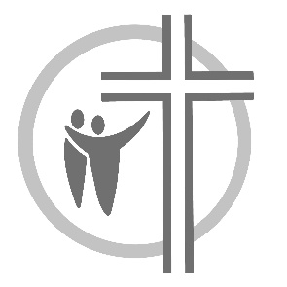
Bethlehem Covenant Church
of Wheaton Minnesota

Associate Pastor Job Profile

Bethlehem Covenant Church is a vibrant, Christ centered community, with a commitment to connecting all generations to Jesus. We are a town and country church located in Wheaton, Minnesota, and a member of the Northwest Conference in the Evangelical Covenant Church.

Our Average weekly attendance is approximately 139 in person, with additional engagement through our online worship services. Bethlehem Covenant Church benefits from strong volunteer participation and a congregation committed to generous living and giving.

Our mission is to be a church dedicated to making fully devoted followers of
Jesus by loving God, loving others and serving in our world. A recently completed expansion provides intentional space for our thriving children’s and youth ministry programs, reflecting our ongoing commitment to the next generation in our surrounding communities.

www.bethcov.org

Position Overview
Working collaboratively with Bethlehem Church leadership and staff, the Associate Pastor will be pivotal in nurturing a culture of outreach and evangelism, supporting the Sunday morning experience, and providing critical support to the Lead Pastor. This role is essential in developing and equipping leaders that align with Bethlehem Church’s vision of connecting all generations to Jesus in our regional communities. This includes overseeing youth ministry teams and adult discipleship pathways. This full-time role presents a unique opportunity for someone passionate about leadership, ministry, discipleship formation and worship.

Candidate Attributes
- The candidate shall possess a vital spiritual life and a passion for evangelism and discipleship.
- Proven leadership in rural/small town ministry, effective communications skills, and a systems mindset.
- They should have an appreciation for the rural church in a community context.
- Candidate shall possess the ability to leverage the congregation’s strengths for relational, wholistic Kingdom impact, both locally and regionally.

Primary Responsibilities
- Participates regularly in Sunday worship services and Wednesday midweek ministries.
- Oversees youth ministry and volunteer youth leaders.
- Oversees, develops and implements adult discipleship pathways.
- Provides teaching and periodic preaching in worship and ministry settings.
Other Responsibilities May Include
- Collaborating with staff and volunteers to work with mission partners
- Leading prayer and outreach initiatives
- Providing pastoral care and counseling

Specific Roles and Responsibilities will be determined based on the selected candidate’s gifts and competencies.

For all inquiries, questions, or requests for the application process for our Associate Pastor position, email us at: searchteam@bethcov.org

Initial application deadline is February 20, 2026

