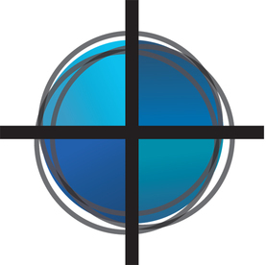
Minister for Community
First Congregational Church
River Falls, Wisconsin

First Congregational Church United Church of Christ of River
Falls, Wisconsin seeks an ordained pastor for part-time ministry
focused on nurturing community and engaging in mission.

Position and Salary
Part-time, .25 FTE
$20,000

Position Description
The Minister for Community is responsible for nurturing relationships within the congregation, reaching out to new members, providing pastoral care, supporting the congregation’s mission, as well as preaching and leading worship approximately every five weeks. The Minister for Community will work collaboratively with the pastoral staff and directly with church committees, groups, and lay leaders to fulfill the responsibilities of this position.

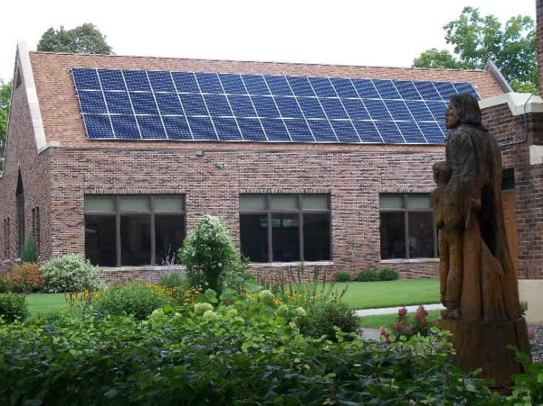
Congregation Description
First Congregational Church is a vibrant congregation eager to spread the good news of God’s love, grace, peace, and justice within and beyond the River Falls community. The congregation welcomes people of all ages and backgrounds to strengthen their faith, participate in a church community, and make a difference in the world. First Congregational Church is dedicated to meaningful worship, strong preaching, exceptional education, effective pastoral care, and faithful mission. The new Minister of Community will join a staff that includes a Senior Pastor, Minister of Christian Education, Youth Ministers, church secretary and office manager, musicians, and custodian.

Community Description
River Falls is a growing community thirty minutes east of the Twin Cities of Minneapolis-St. Paul, located along the scenic Kinnickinnic River in western Wisconsin. With a population of 16,000, a campus of the University of Wisconsin, and the Chippewa Valley Technical School, River Falls is a thriving community. As a community, River Falls cares about the environment, ranking first in the state and fifth in the nation for green energy usage. River Falls fosters community engagement, hosts local festivals, and is served by active churches, civic organizations and clubs. First Congregational Church is located two blocks from Main Street in a recently renovated, expanded and fully accessible building which supports a wide range of church and community outreach programs. Please see: www.firstchurchrf.org.

For more information, contact: office@firstchurchrf.org.

