## 

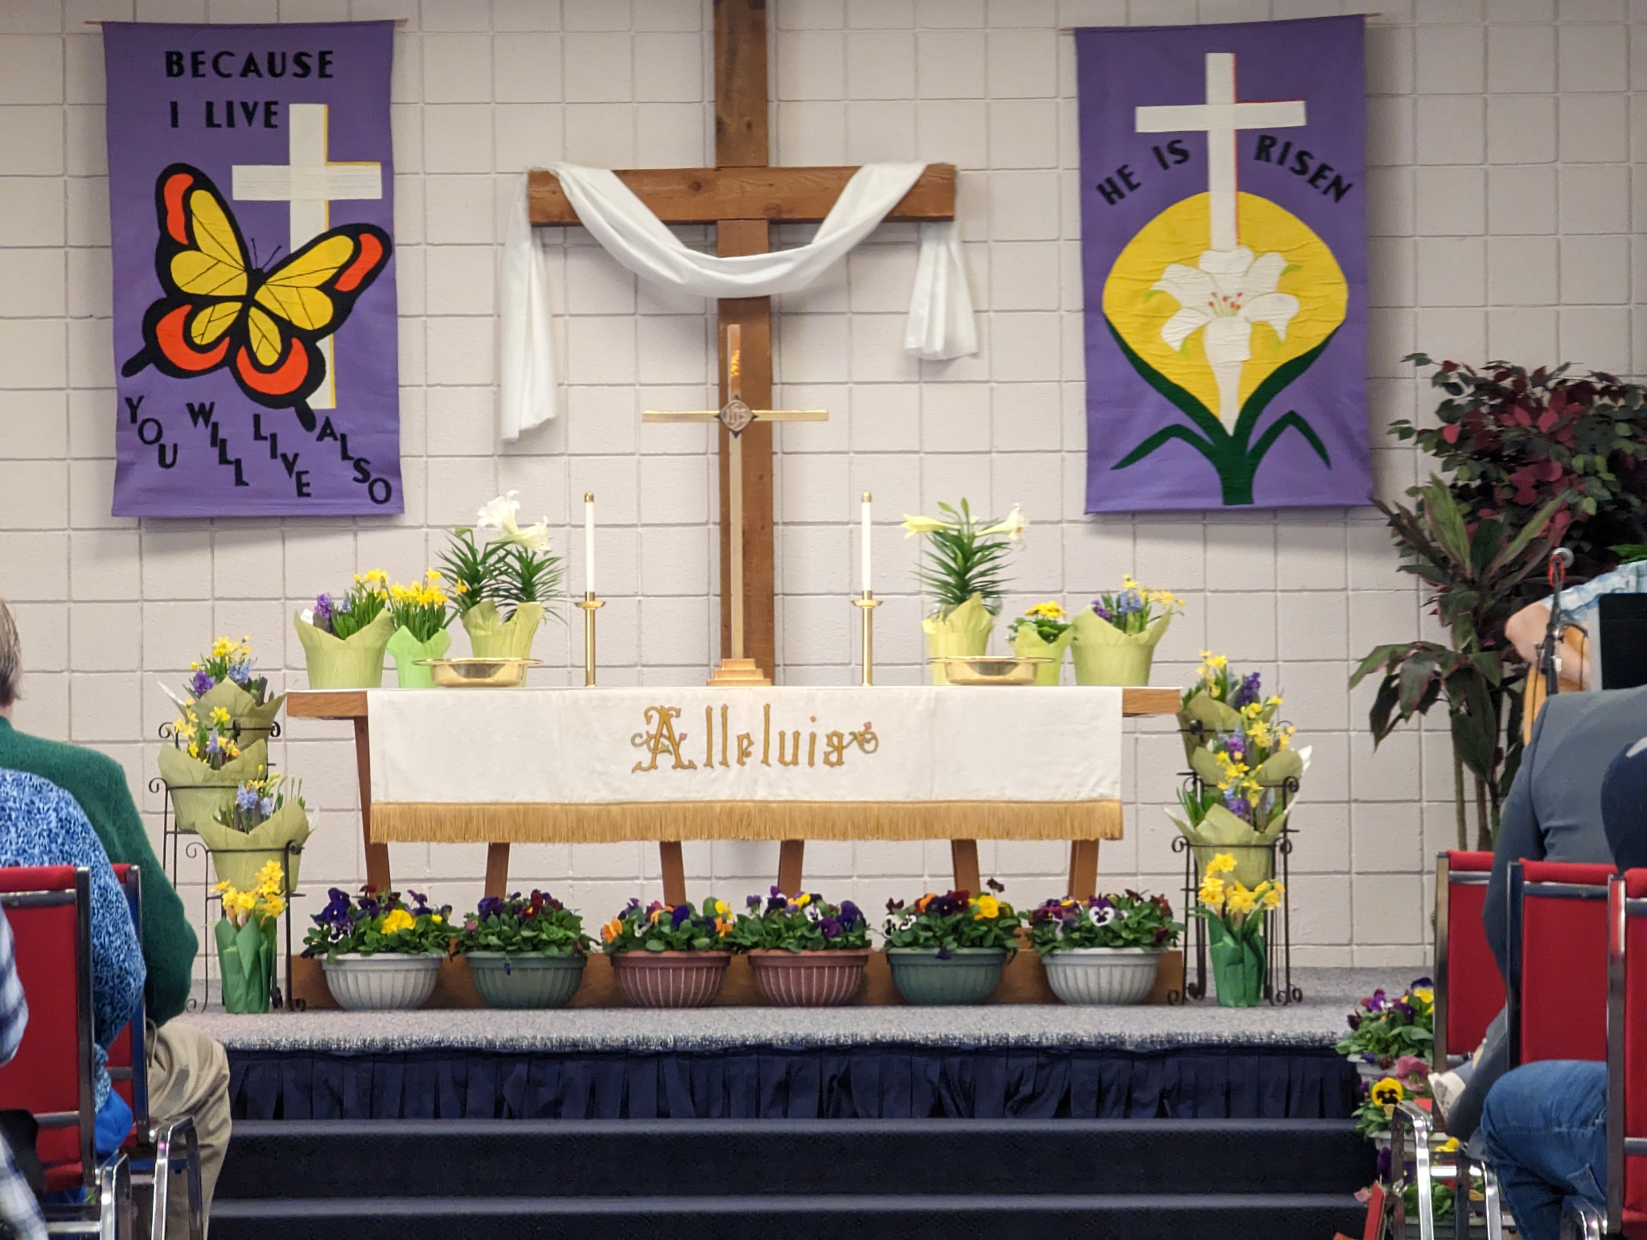

SouthCross Community Church

Established 2001

Burnsville, MN

**─**

At SouthCross Community Church, a welcoming and affirming congregation, we seek to create a strong sense of community through joyful worship and fellowship while extending the sense of community beyond our walls through faithful service.

# What We Believe

This church accepts the Bible as the authoritative Word of God and the only rule of faith and practice. We accept the Lord Jesus Christ as our Savior and as the head of the church, and that He and His teachings are the model for Christian living.

# A Brief History

SouthCross Community Church is the result of a merger between Valley Community Church and Promise Congregational Church in September of 2001. While Valley was founded in 1966, the building we meet in was raised in 1970 and was noted for their community outreach and involvement and the famous Living Nativity which continues to this day. Promise was created in 1992 and was recognized for their commitment to children, as evidenced through their annual community VBS and participation in local parades. Now, as one, we have retained what was important and unique about each previous congregation and serve our community through ministry and outreach.

# Small But Mighty in the Community

We believe we have been commissioned by God to not exist solely for its own members, but to serve the world in which we live, and to try to make it a better place for all. SouthCross Community Church picks a different mission to support each month. Some ongoing mission projects are the local food shelves and shelter, as well as international missions including Operation Christmas Child, and the missions that are sponsored through our affiliations with the American Baptist Churches USA and the National Association of Congregational Christian Churches.

To find out more about our church’s history and mission, please visit our website here: <https://www.southcrossmn.org/page/home-page>

# Pastoral Expectations

## Pastoral Care

Pastoral care is an integral part of our congregation. The pastor needs to get to know congregants at fellowship time and by attending church events in order to become a trusted resource where individuals can bring confidential items to them. The pastor should make reasonable accommodations to visit those who are ill and stay aware of activities or events congregants may participate in on their own time. The pastor does not need to reach out on a regular basis but as needed and instinctually be aware of the need to be involved.

## Preaching & Interpreting the Faith

Preaching the word of God and message of Jesus for everyday living is important. We are looking for someone who is engaging and provides an easy to follow message that is relatable and something to use each day. A pastor should take the scripture and relevant Bible story and interpret it by breaking it down to apply to a person’s everyday living. We enjoy the use of personal stories and other examples are welcomed as long as the central message stays as the interpretation of the Word.

## Church Growth

Growth and sustainment is of particular importance at this time. While the pastor is not expected to be the leader in encouraging growth, it is an expectation to work closely with the Membership & Evangelism committee to help determine the best ways to support outreach. We need someone who will have ideas to contribute, and work jointly with council members to implement them. As a leader or figurehead of the church, it's important to have a pastor with a vision to help assist in growth and sharing the Word with the community.

## Education

SouthCross believes in Christian education across all ages. While our pastor is not expected to lead these classes, they should provide ideas, direction and encourage participation in christian education.. The exception would be Confirmation, as the expert, a pastor would be in charge of this pivotal class.

## Communication

Our congregation values consistent communication to stay connected. This includes both general communication with the congregation as a whole, and with individuals. A pastor should be comfortable sending out a short weekly email, or similar, with some inspirational message or thoughts for the week. Communicating with individuals should be done as needed, i.e. connected to pastoral care or the needs of the church. Direct, clear, and respectful communication is expected from both the pastor and members of the congregation. The pastor should feel comfortable addressing any issues in an appropriate manner.

## Worship Style

Our service is a blend of traditional and contemporary music. The praise band is led by our pianist/music director and is regularly accompanied by a percussionist, guitarist, and clarinetist with occasional guest musicians. We also have an adult choir and chime choir who regularly perform during the service. Communion is served on the first Sunday of each by intinction. Baptisms are performed by affusion or aspersion, or by immersionupon request. Baptismsare offered to people of any age.

## Fellowship & Engagement

SouthCross is looking for a pastor to be an involved member of the community. Ideally, the pastor would be a local resident and attend youth group, vacation bible school, and adult ed as they are able. We want a strong figurehead at church events, such as the Thanksgiving dinner and VBS. We are looking for a dedicated pastor who is comfortable meeting and greeting new people who may want to become more involved with our church. Our youth have asked for a pastor to be present and involved with their activities and guiding their spiritual growth.

# Compensation:

* We are currently looking for a half or three-quarter time pastor with a salary range of $30k - $45k per year depending on availability and experience. Designation of wages as housing allowance is negotiable, however, deductions for healthcare, phone, auto, or other work expenses are not available at this time.
* Bi-vocational pastors are welcomed!
* Vacation: 4 full weeks off during the summer (not to conflict with VBS the first week of August) + an additional 3 Sundays to be used throughout the rest of the year
* Reimbursement of travel costs related to denominational meetings and continuing education stipend offered
* Possibility of sabbatical after 5 years in the position
* Open to other compensatory options!

# Location

Being part of the local community is an important part of our congregation, and we are looking for someone located within approximately 30 minutes of the church. If relocation is needed, we are open to discussion of moving assistance.

# Pastoral Search Committee

Vicky Limesand- Chairperson

Jennifer Largen

Jen Connolly

Tim Peterson

Chris Ockwig

Glenn Springer

To Apply email resume to  [sccpastoralsearchmn@gmail.com](mailto:sccpastoralsearchmn@gmail.com)